A DESIGN PROJECT REPORT

PRESENTED TO THE ENGINEERING DIVISION OF THE IQRA UNIVERSITY

BY

ABDULLAH SIDDIQUI

PROJECT ADVISOR: FAROOQ IQBAL

DUE DATE: 15 JANUARY

Table of content

Introduction ………………………………………………… 1

Explanation ……………………………………………….... 1

Data and table ……………………………………………… 2

Database schema’s …………………………………………. 3

Windows form explanation …………………………………. 4

ERD …………………………………………………………. 4

Screenshots ………………………………………………….. 5

Conclusion ………………………………………………….. 6

Tools ………………………………………………………... 6

**PROJECT NAME:** *BAKERY MANAGEMENT SYSTEM*

**AUTHOR NAME**: *ABDULLAH SIDDIQUI*

**INTRODUCTION:**

The bakery management software is about making a database for the bakery to make the record of the employee's, sales/purchase and products. Bakery management system will allow owners to maintain their record in one place which will be easy to manage it will also reduce the risk or errors.

**EXPLAINATION:**

In my project “Bakery Management System” defines a bakery sales point of view. This system contains many options for example, we can add many items into the cart. It has the remove option in which we can remove items which was add up in the cart. It contains a discount option so that the customers can avail discounts on purchase. Every customer will have their personal ID numbers which will help us to maintain the record. This system automatically keep update the records of customers like or dislike.

**DATA AND TABLES:**

CREATE TABLE [dbo].[Login]

(

[Id] INT NOT NULL,

[pass] VARCHAR (10) NULL,

PRIMARY KEY CLUSTERED ([Id] ASC)

);

...............................................................................................

CREATE TABLE [dbo].[details]

(

[MasterID] INT IDENTITY (1, 1) NOT NULL,

[InvoiceID] INT NULL,

[ItemName] VARCHAR (50) NULL,

[ItemPrice] INT NULL,

[ItemQtty] INT NULL,

[ItemTotal] NUMERIC (18, 2) NULL,

CONSTRAINT [PK_details] PRIMARY KEY CLUSTERED ([MasterID] ASC)

);

......................................................................................

CREATE TABLE [dbo].[master]

(

[InvoiceID] INT NOT NULL,

[Invoice_Date] DATE NULL,

[Discount] INT NULL,

[Net_amount] INT NULL,

[Paid_amount] INT NULL,

[Balance] AS ([Paid_amount]-[Net_amount]),

CONSTRAINT [PK_master] PRIMARY KEY CLUSTERED ([InvoiceID] ASC)

);

**DATABASE SCHEMA EXPLAINATON:**

It defines the structure and content in each data element within the structure. Schemas are often designed with visual modeling tools that automatically create the SQL code necessary to define the table structures.

**1st table**:

•The first table is of login having two fields that are login ID and password.

•The datatype of login id is integer and the data type of password is varchar.

**2nd table**:

•The second table is of details having six fields that are MasterID, InvoiceID, ItemName, ItemPrice, ItemQtty, ItemTotal.

•The datatype of MasterID is integer, InvoiceID is integer, ItemName is varchar, ItemPrice is integer, ItemQtty is integer and ItemTotal is numeric.

**3rd table**:

•The third table is of master and is also having six fields that are InvoiceID, Invoice_Date, Discount, Net_amount, Paid_amount, Balance.

•The datatype of InvoiceID is integer, Invoice_Date is date, Discount is integer, Net_amount is integer, ,Paid_amount is integer and Balance define as ([Paid_amount]-[Net_amount]).



**Windows form application function:**

•The first window application form is login in which we give username / id and password to access the main screen.

•The second window application form is so called main screen. In this screen we have several items to select such as sweets, beverages, nimko, savory items and bakers. After selecting an item we must have to select one or more than one dish or items to continue our project. Once you select an item than price of this item shown in price box by itself. Then you enter the quantity of items then the total price of item will be show in the total price box and then you click the add to cart button to add the item and the price of the item in the cart box. There is also a button of remove item, the function of this button is to remove item from the cart. Then we have a discount option in which we give discount to our costumer. Then there is a net amount box in which the total amount of all items show after discount. Then there is a paid amount box in which we enter the amount which is given by costumer. Then there is a balance amount box in which we show the result of subtraction of net amount box and paid amount box. And also we assign a unique id to our costumer. And there is a button of save in which all the data would be save and also a button of clear. By clicking this button all the data would clear.

**ERD DIAGRAM:**

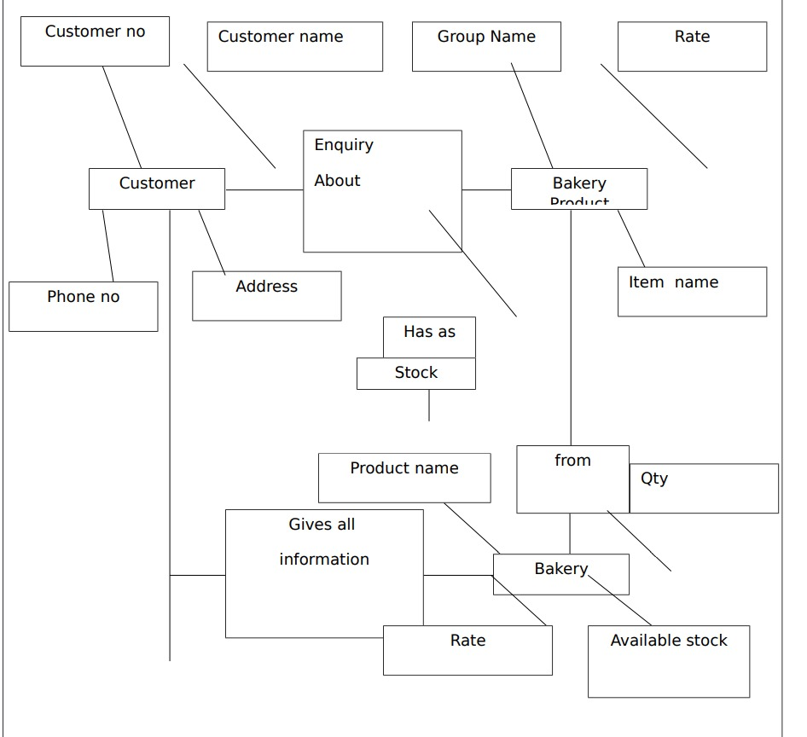

**Login page**

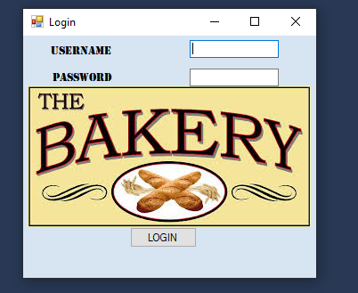

**Id pass**

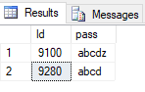

**front page**

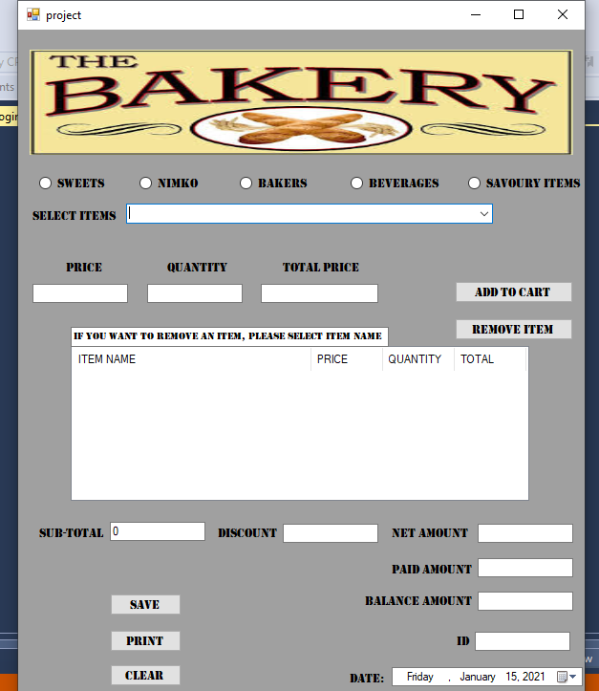

**Order page**

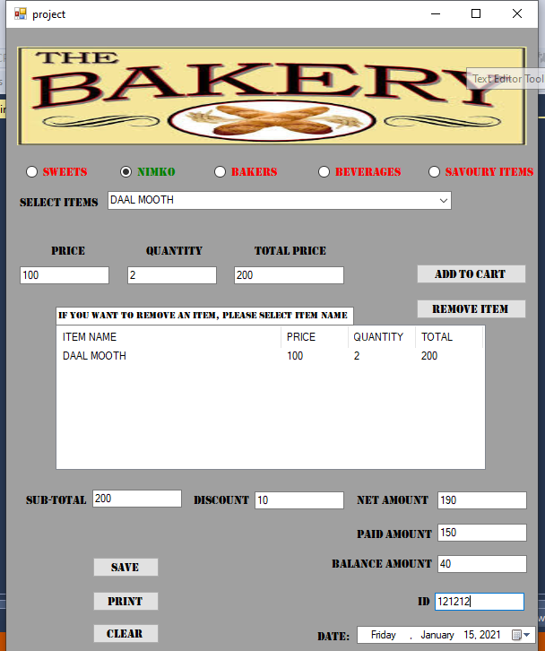

**CONCLUSION:**

* The system shall provide a convenient interface for User Registration, Categories, Items Search and Payment.
* The system should be able to show bakery products in their respective categories.
* The system shall provide different options for discount (10%, 15%, and 20%) on various bakery items.
* Every order shall be allocated a unique identifier (ORDER_ID).

**TOOLS:**

ASP.NET, SQL Server, MYSQL